Nursing Burn Course

Learn:
- The physiological effect of thermal, chemical & electrical injury
- The steps in the primary & secondary assessment
- The risk factors & the clinical manifestations of inhalation injury
- The risk factors & the clinical manifestations of electrical or chemical burns
- Perioperative care of the burn patient
- Management of nutrition in the burn patient
- Rehabilitation process in burn patients
- Treatment options in burn wound care

February 25, 2022 7:45am-2:30pm
Location: DePalma Auditorium versus Virtual on Zoom-
To Be Determined by 2/18/2022. All registered participants will receive an email with details by 2/18/2022.

Scan QR code to go to Jefferson NCPD website and register:
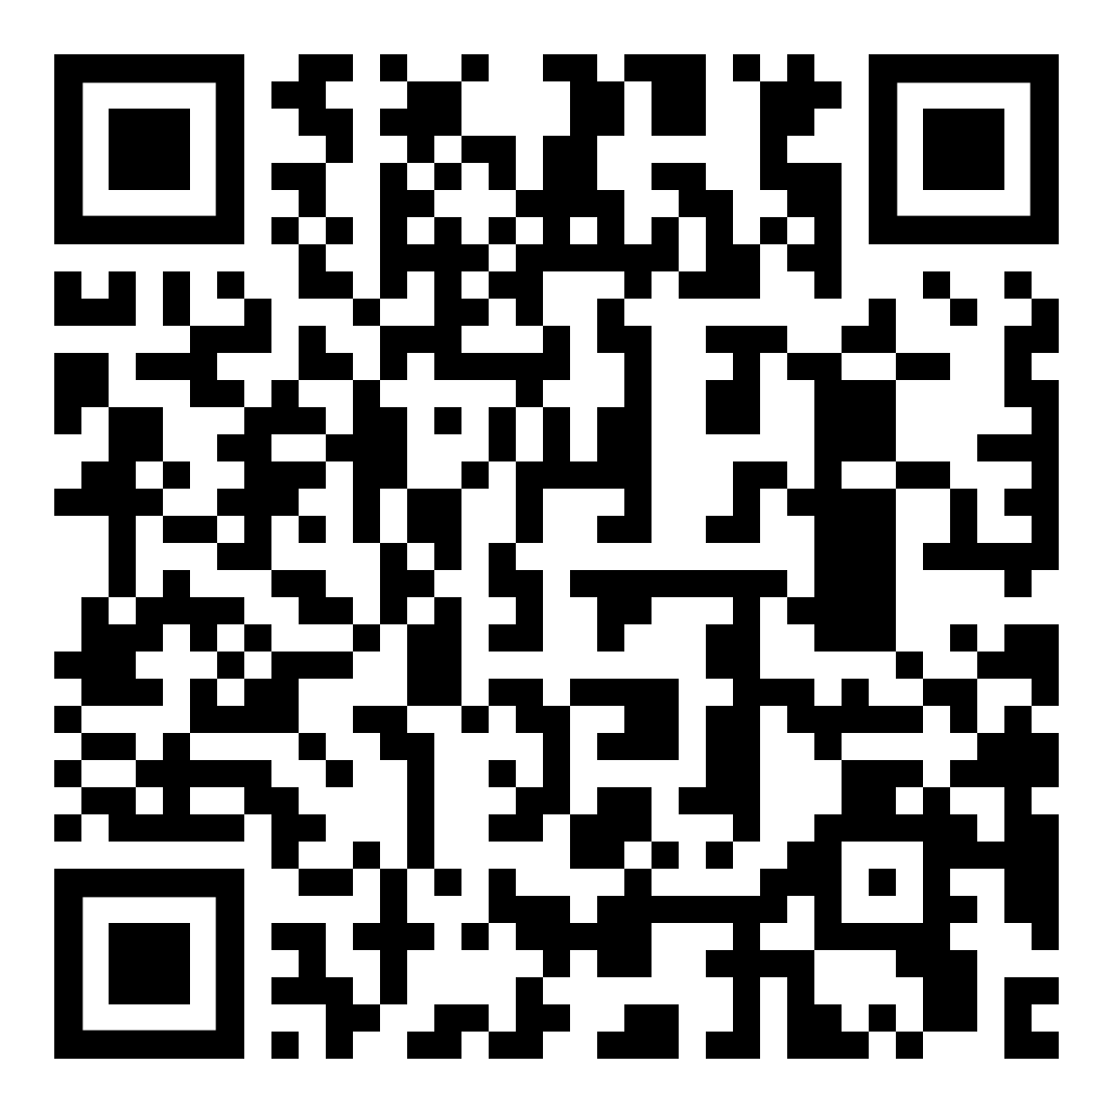

For more information -
Contact: Jessica Byrne, MSN, RN-BC, CCCTM
Jessica.byrne@jefferson.edu

